How to Troubleshooting for PAX - BOFA

1) Network Error 1001 :-
A. Verify the Pax and iPad are on same network.
The Internet connection is the gateway to connect all devices on the network to communicate with one another. Please make sure Pax and Ipad are connected to the same network.

B. Verify the IP of the Pax is same under the Rapid Application > Settings > Pax Configuration > IP Address.
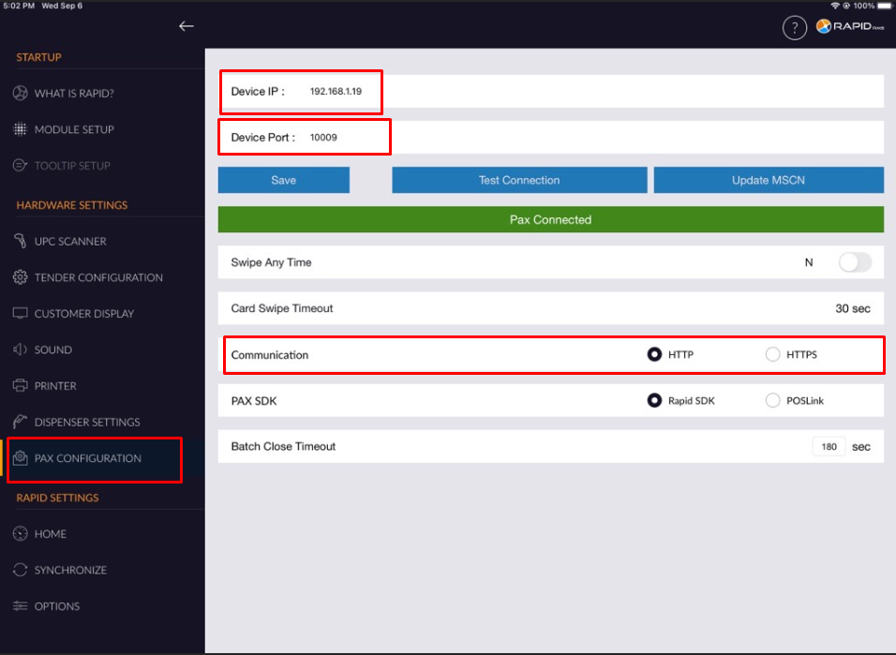
C. Verify that Pax is configured for External POS (Pax to POS communication).

Please follow below steps and screenshort to verify the same.

- Open Your BOFA Application from Home Screen.
- Click on Setting icon.
- Enter a password 1 and click on Enter button.
- Find “System Settings” and click Enter.
- Select the ECR Terminal Integration Mode and click Enter.
- Select External POS.

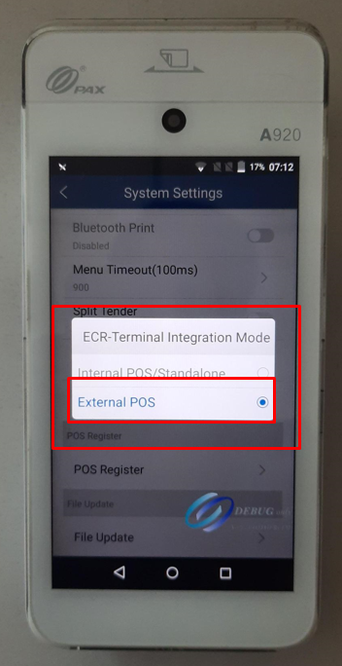

2) Restart the devices if #1 steps are configured correctly :-
A. Restart the Pax
B. Restart the iPad
C. Repeat Step #1
3) SSL Error :-
A. Verify the ECR Setup.
i. Communication: Ethernet
ii. Protocol: HTTP Get (Preffered for default) or HTTPS Get
Please follow below steps and screenshort to verify the ECR Setup.
- Open Your BOFA Application from Home Screen.
- Click on Setting icon.
- Enter a password 1 and click on Enter button.
- Find “ECR Comm Settings” and click Enter.
- Select the Ethernet option and click Enter.
- Port will display as 10009, Click enter again.
- Select HTTP Get or HTTPS Get and click on enter.

Note:- Please make sure that HTTP and HTTPS options should be selected according to Pax configuration settings from IPad.
Processor | Protocol
All Processor | It supports HTTP GET and HTTPS GET Protocol.
TSYS Processor | It supports HTTP GET Protocol only.
- Exit to main screen by pressing < on the device.

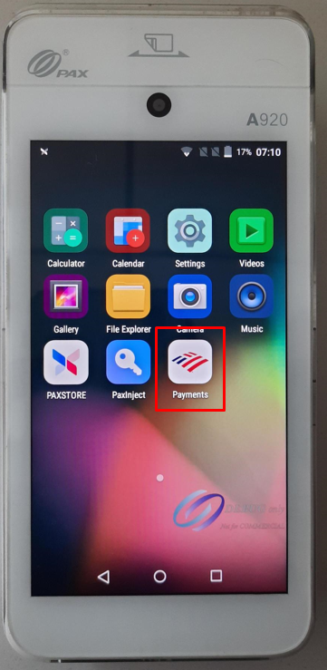

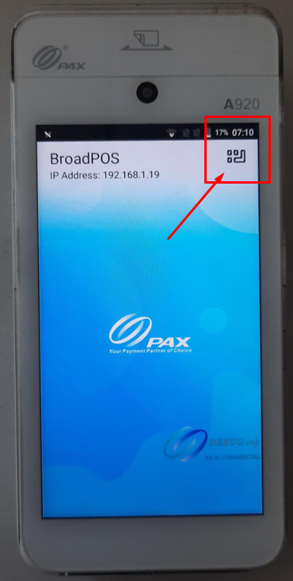

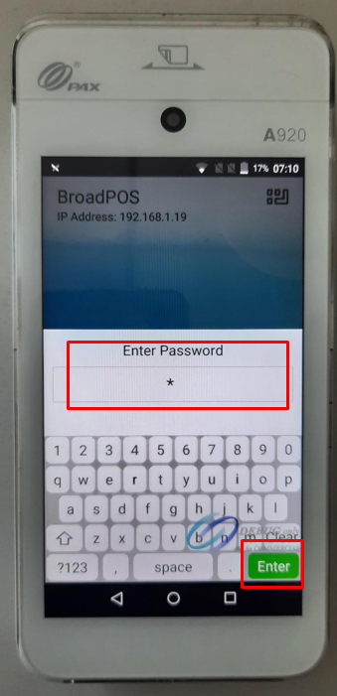

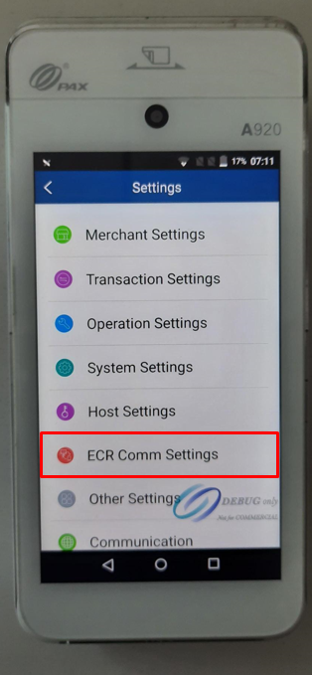

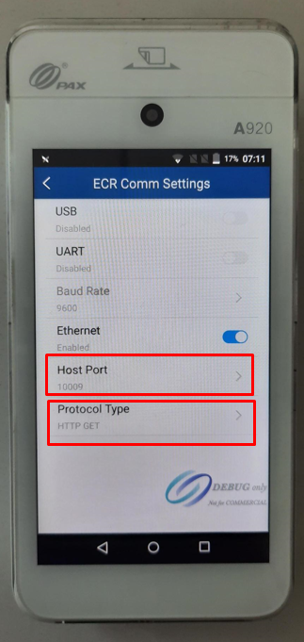

B. Go to Rapid Application and match the configuration for protocol under Pax Configuration.



